**ASBAT EXAMINATIONS BOARD**

**MIDTERM II EXAMINATION 2023**

**Age Group (5 – 6 years): TOP CLASS**

**Learning Area 2: English**

My name is ______________________________________________

**School: _________________________________________________________**

1. **Change from small letters to capital.**

read READ tick ___________

roy ____________ elephant __________

giraffe ___________ church ___________

1. **Fill in the letters after these.**

a b c ___ ____ ___ ____ ____

i j k ___ ____ ___ ____ ____

q r s t u v ____ ___

y z

1. **Read and draw.**

bird flower church

ball stone mosque

1. **Name these activities.**

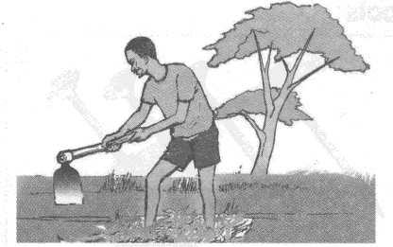

sweeping

teaching

digging

cooking

mopping

______________

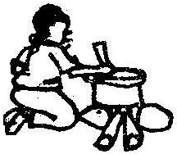

______________

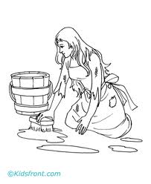

______________

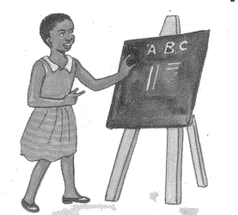

______________

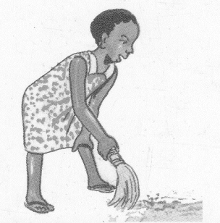

______________

1. **Make sentences using This is a …….**

This is a butterfly

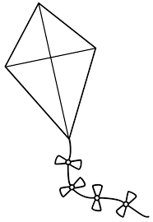

_________________________

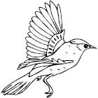

__________________________

_________________________

(bird, kite, balloon, butterfly)

1. **Fill in the missing letters.**

|  |  |  |
| --- | --- | --- |
| te___cher | t___ee | c___w |
| fl___w___r | ___nsect | https://encrypted-tbn1.gstatic.com/images?q=tbn:ANd9GcTWaW9UIqk5DX7Zwy70El2onBY342OJeO-7DnoMcByAeo0gLwWbSA  bi____d |

1. **Match to the belonging.**

farmer shop

teacher church

doctor mosque

imam school

priest police station

shopkeeper garden

policeman hospital

**END**